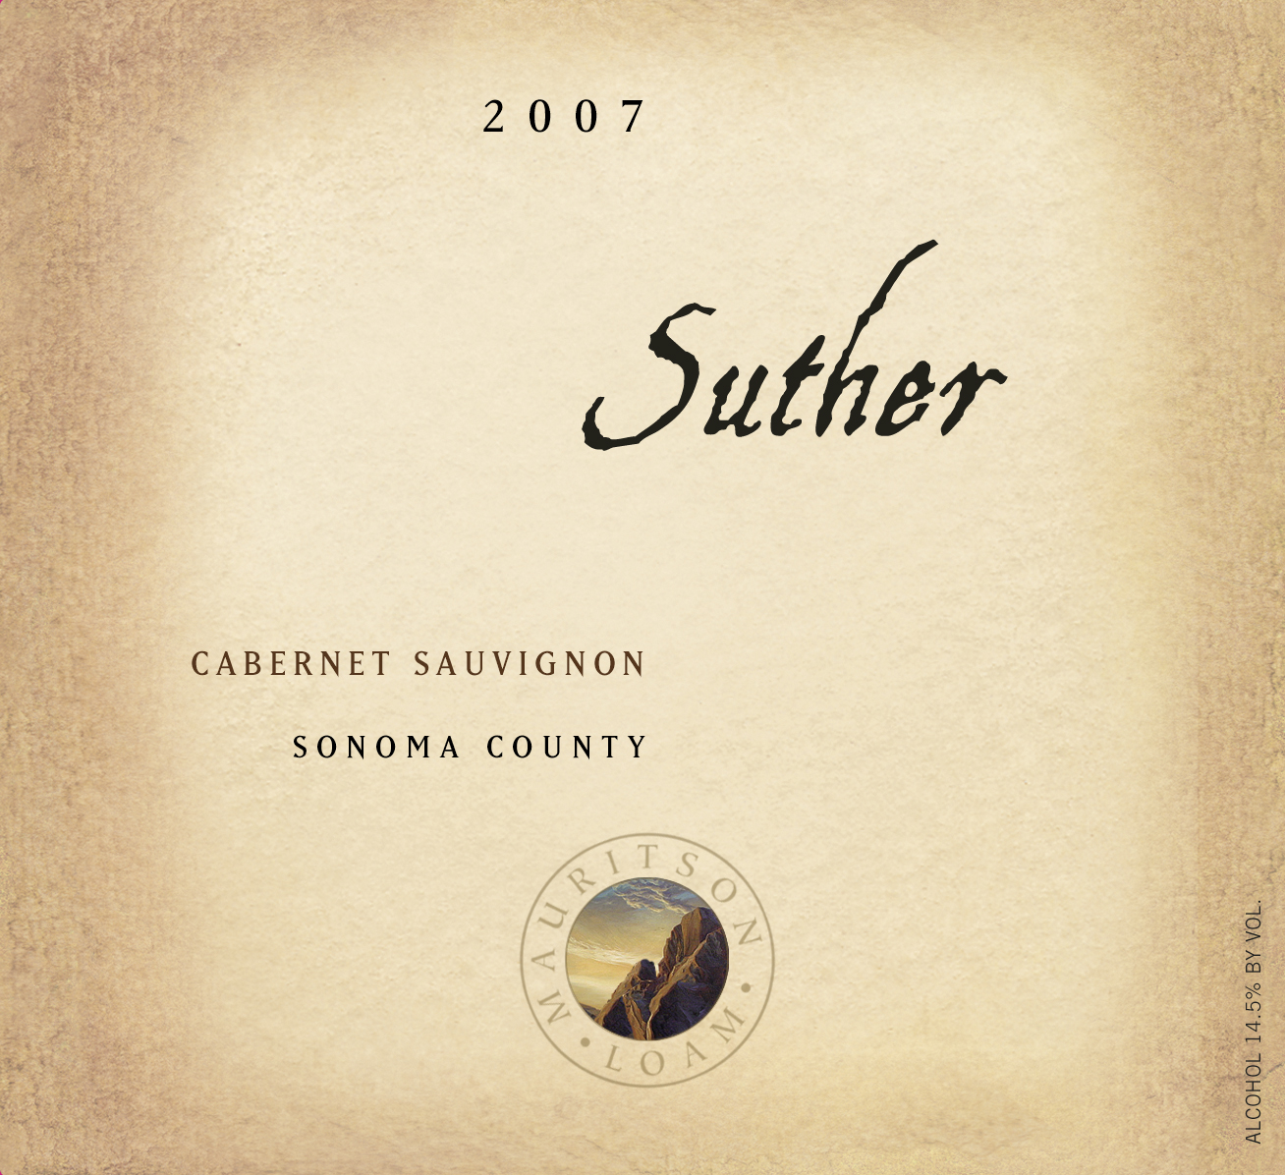

LOAM SINGLE-SOIL SERIES

2007 Suther Sonoma County Cabernet Sauvignon

Production: Approximately 95 cases
Appellation: Sonoma County
Composition: 100% Cabernet Sauvignon
Soils: Suther
Alcohol: 14.5 % by volume
Aging: 26 months oak barrels, 100% French

Winemaker Notes

Weathered from metamorphic rock, Suther is a gravelly Loam found on the side slopes of mountains underlain by sandstone and shale. Primarily located between 500-3000 feet in elevation, Suther soils are only found in the geographic locations associated with great Cabernet Sauvignon. The granular structure and shallow nature of Suther soils provide little water retention and minimal biologic activity, while increased sun and wind exposures ensure low vigor, small berry formation, and uniformity in ripeness. Suther soils tend to nutrient deficient, lacking in nitrogen, phosphorus, and boron. The reddish nature is indicative of oxidized soils that are high in iron content. With a pH ranging from 5.5 to 6.0, Suther soils are moderately acidic.
In its second vintage, the 2007 Suther Cabernet Sauvignon is everything that you would expect it to be: classic Cabernet that exemplifies the nuances of a specific stratum of soil. The ripe cherry fruit on the nose is accented by hints of mineral and sweet oak. Combining power and finesse, the tannins are silky and rich. Perfectly balanced, this Cabernet will be most enjoyable from 2011-2018.

